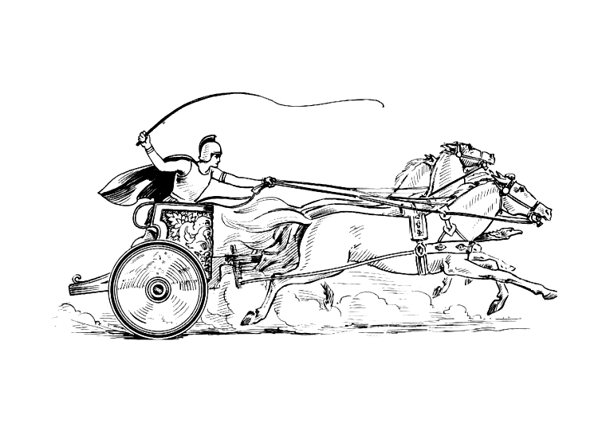Manduessedum - Mancetter Village (Place of War Chariots)
Mancetter Parish Council
Serving the People of Mancetter and Ridge Lane

You are invited to the Parish Council Meeting
being held in the Bracebridge Room at St Peter’s Church Mancetter
on Tuesday 26th September 2023 at 7pm.

AGENDA

- Welcome and Apologies.

- Chairman’s request that anyone recording the meeting make themselves known, to allow
openness and recognise practicalities.

- Declared Notice of Interest by Councillors concerning Agenda items.

- Public Question time of up to 15 Minutes for Parishioners to raise issues.

- Police, County and Borough Councillor feedback.

- Minutes of the last meeting.

- To accept the draft minutes of the Parish Council Meeting held on 1st August 2023.

- Matters Arising from the Parish Council Meeting on 1st August 2023
not covered in any other Agenda points.

- Update on Parish Councillor Vacancy.
- Feedback from the County Council Road Safety Team.
- Progress report on the Levelling Up work, Climate Change and Cost of Living Agenda.

- Finance

- Signing of all payments in accordance with standing orders and the bank mandate.
- Confirmation of successful completion of external audit.
- Status of Internet Banking and Mandate authorities.
- To consider alternative costing options for procurement of parish notice boards including restoration and relocation.
- To authorise expenditure for a replacement printer for the Parish Office.
- To begin preparation for the 2024 2025 budget and precept setting process by looking at current budgets, insurance implications and identifying expenditure requirements.

- Planning Matters and New Applications since the previous meeting

- Update on Approved, Rejected, Pending Applications and Appeals.

- PAP/2023/0100 – Mancetter Marina - Variation of conditions 2 and 6 of planning permission 0023/92/FAP dated 30/10/1992 - Granted
- Notification of an Appeal Hearing regarding an application for 7 Holiday Lodges at Delamere in Purley Chase Lane. - Pending

- PAP/2023/0229 – Mancetter Wharf – Erection of Office Building including landscaping and parking - Pending
- PAP/2023/0280 – Sovereign Motor Company – Proposed extension to existing vehicle workshop to be used as an MOT facility. - Pending
- PAP/2023/0283 – Sovereign Motor Company – Change of use for part of site to vehicle sales - Pending
- PAP/2023/0299 – 12 Mancetter Road – Demolition of existing conservatory and construction of a new rear extension. - Granted

- To discuss any new applications received.

- PAP/2023/0324 – Outline Access application for construction of three dwellings to the rear of the White Hart Inn Ridge Lane.
Including Highways comments and feedback from parish meeting on 20th September 2023.

- PAP/2023/0334 – Change of use from Agricultural to Residential The Dutch Hay Barn Whitehall Farm Atherstone Road Hartshill.
10 Date of next meeting:
Tuesday 28th November 2023 7pm at St Peter’s Church Mancetter.

Signed
Date 21st September 2023.
Elane Higgins
Parish Clerk Mancetter Memorial Hall Old Farm Road Mancetter CV9 1QN Tel: 01827 722552 / 07368 265051
Email: parishclerk@mancetter.org.uk
Website: www.mancetter.org.uk

